9.Write a Python programs to create Figure Aesthetics, Contexts, Color Palettes, using Pandas DataFrame in Seaborn (reading .csv file in Pandas DataFrame) for the following plots:

i)Line plot

ii)Scatter plot

**team.csv**

|  |  |  |  |  |  |
| --- | --- | --- | --- | --- | --- |
| Name | Team | Number | Position | Age | salary |
| Avery Bradley | A | 12 | PG | 25 | 2500 |
| Jae Crowder | B | 34 | SG | 25 | 4545 |
| John Holland | C | 12 | SG | 27 | 2323 |
| R.J. Hunter | D | 56 | SG | 22 | 2324 |
| Jonas Jerebko | E | 67 | PF | 29 | 1456 |
| Amir Johnson | F | 56 | PF | 29 | 2324 |
| Jordan Mickey | G | 78 | PF | 21 | 6754 |
| Kelly Olynyk | H | 34 | PG | 25 | 3421 |
| Terry Rozier | I | 67 | PG | 22 | 890 |
| Marcus Smart | J | 45 | PG | 22 | 5678 |

i)**Line plot**

**Program:**

import seaborn as sns

import matplotlib.pyplot as plt

import pandas as pd

data = pd.read_csv("C:\\Users\\JOSHITH\\Desktop\\team.csv")

print(data)

# plotting a single line graph

sns.lineplot(x="Team", y="Number", data=data, hue="Position", palette="bright")

sns.set_style("dark",{'axes.axisbelow':False,'axes.grid':True,'grid.color':'red'})

sns.set_context("notebook",font_scale=1,rc={'figure.figsize':(8,5)})

plt.title("Line plot in Seaborn",color="blue",fontsize=20)

p=sns.color_palette("deep")#deep,colorblind,dark,pastel,bright

sns.palplot(p)

plt.show()

**Output:**

Name Team Number Position Age salary

0 Avery Bradley A 12 PG 25 2500

1 Jae Crowder B 34 SG 25 4545

2 John Holland C 12 SG 27 2323

3 R.J. Hunter D 56 SG 22 2324

4 Jonas Jerebko E 67 PF 29 1456

5 Amir Johnson F 56 PF 29 2324

6 Jordan Mickey G 78 PF 21 6754

7 Kelly Olynyk H 34 PG 25 3421

8 Terry Rozier I 67 PG 22 890

9 Marcus Smart J 45 PG 22 5678

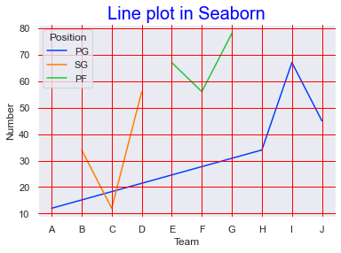



**ii)Scatter Plot:**

import seaborn as sns

import matplotlib.pyplot as plt

import pandas as pd

data = pd.read_csv("C:\\Users\\JOSHITH\\Desktop\\team.csv")

print(data)

sns.scatterplot(x="Team", y="Number", data=data, hue="Position", palette="bright")

sns.set_style("dark",{'axes.axisbelow':False,'axes.grid':True,'grid.color':'red'})

sns.set_context("notebook",font_scale=1,rc={'figure.figsize':(8,5)})

plt.title("Scatter plot in Seaborn",color="blue",fontsize=20)

p=sns.color_palette("deep")#deep,colorblind,dark,pastel,bright

sns.palplot(p)

plt.show()

**Output:**

Name Team Number Position Age salary

0 Avery Bradley A 12 PG 25 2500

1 Jae Crowder B 34 SG 25 4545

2 John Holland C 12 SG 27 2323

3 R.J. Hunter D 56 SG 22 2324

4 Jonas Jerebko E 67 PF 29 1456

5 Amir Johnson F 56 PF 29 2324

6 Jordan Mickey G 78 PF 21 6754

7 Kelly Olynyk H 34 PG 25 3421

8 Terry Rozier I 67 PG 22 890

9 Marcus Smart J 45 PG 22 5678

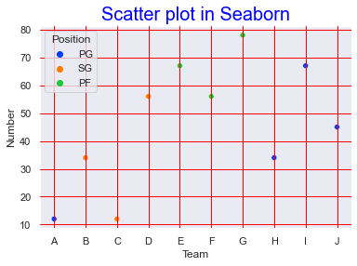



10. Write a python programs to create Figure Aesthetics, Contexts, Color Palettes using Dictionaries in Pandas in Seaborn for the following plots:

i)Histogram

ii)Bar plot

**i)Histogram:**

**Program**

import seaborn as sns

import matplotlib.pyplot as plt

import pandas as pd

data = pd.DataFrame({'Name': ['Avery Bradley', 'Jae Crowder', 'John Holland', 'R.J. Hunter', 'Jonas Jerebko', 'Amir Johnson',

'Jordan Mickey', 'Kelly Olynyk','Terry Rozier','Marcus Smart'],

'Team': ['A','B','C','D','E','F','G','H','I','J'],

'Number':[12,34,12,56,67,56,78,34,67,45],

'Position':['PG','SG','SG','SG','PF','PF','PF','PG','PG','PG'],

'Age':[25,25,27,22,29,29,21,25,22,22],

'salary':[2500,4545,2323,2324,1456,2324,6754,3421,890,5698]

})

print(data)

sns.histplot(data = data, x = "Number", kde = True, hue = "Position", palette="Greens")

sns.set_style("dark",{'axes.axisbelow':False,'axes.grid':True,'grid.color':'red'})

sns.set_context("notebook",font_scale=1,rc={'figure.figsize':(8,5)})

plt.title("Histogram plot in Seaborn",color="blue",fontsize=20)

p=sns.color_palette("deep")#deep,colorblind,dark,pastel,bright

sns.palplot(p)

plt.show()

**Output:**

Name Team Number Position Age salary

0 Avery Bradley A 12 PG 25 2500

1 Jae Crowder B 34 SG 25 4545

2 John Holland C 12 SG 27 2323

3 R.J. Hunter D 56 SG 22 2324

4 Jonas Jerebko E 67 PF 29 1456

5 Amir Johnson F 56 PF 29 2324

6 Jordan Mickey G 78 PF 21 6754

7 Kelly Olynyk H 34 PG 25 3421

8 Terry Rozier I 67 PG 22 890

9 Marcus Smart J 45 PG 22 5678

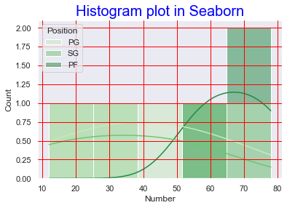



**ii)Bar plot:**

**Program:**

import seaborn as sns

import pandas as pd

import matplotlib.pyplot as plt

data = pd.DataFrame({'Name': ['Avery Bradley', 'Jae Crowder', 'John Holland', 'R.J. Hunter', 'Jonas Jerebko', 'Amir Johnson',

'Jordan Mickey', 'Kelly Olynyk','Terry Rozier','Marcus Smart'],

'Team': ['A','B','C','D','E','F','G','H','I','J'],

'Number':[12,34,12,56,67,56,78,34,67,45],

'Position':['PG','SG','SG','SG','PF','PF','PF','PG','PG','PG'],

'Age':[25,25,27,22,29,29,21,25,22,22],

'salary':[2500,4545,2323,2324,1456,2324,6754,3421,890,5698]

})

print(data)

sns.barplot(x="Team", y="Number", data=data, hue="Position", palette="bright")

sns.set_style("dark",{'axes.axisbelow':False,'axes.grid':True,'grid.color':'red'})

sns.set_context("notebook",font_scale=1,rc={'figure.figsize':(8,5)})

plt.title("Bar plot in Seaborn",color="blue",fontsize=20)

p=sns.color_palette("deep")#deep,colorblind,dark,pastel,bright

sns.palplot(p)

plt.show()

**Output:**

Name Team Number Position Age salary

0 Avery Bradley A 12 PG 25 2500

1 Jae Crowder B 34 SG 25 4545

2 John Holland C 12 SG 27 2323

3 R.J. Hunter D 56 SG 22 2324

4 Jonas Jerebko E 67 PF 29 1456

5 Amir Johnson F 56 PF 29 2324

6 Jordan Mickey G 78 PF 21 6754

7 Kelly Olynyk H 34 PG 25 3421

8 Terry Rozier I 67 PG 22 890

9 Marcus Smart J 45 PG 22 5698

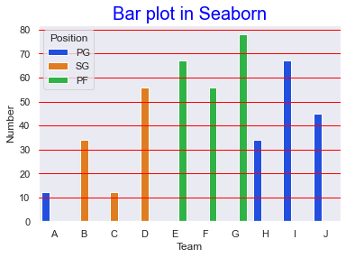



11. Write python programs to create Figure Aesthetics, Contexts, Color Palettes, using Seaborn (loading dataset available in seaborn) for the following plots:

i)Box plot

ii)Histogram

**i)Box Plot:**

**Program:**

import numpy as np

import pandas as pd

import seaborn as sns

# Load dataset

data = sns.load_dataset("fmri")

print(data)

sns.boxplot(x='timepoint', y='subject', data=data, palette="Greens")

sns.set_style("dark",{'axes.axisbelow':False,'axes.grid':True,'grid.color':'red'})

sns.set_context("notebook",font_scale=1,rc={'figure.figsize':(8,5)})

plt.title("Box plot in Seaborn",color="blue",fontsize=20)

p=sns.color_palette("deep")#deep,colorblind,dark,pastel,bright

sns.palplot(p)

plt.show()

**Output:**

subject timepoint event region signal

0 s13 18 stim parietal -0.017552

1 s5 14 stim parietal -0.080883

2 s12 18 stim parietal -0.081033

3 s11 18 stim parietal -0.046134

4 s10 18 stim parietal -0.037970

... ... ... ... ... ...

1059 s0 8 cue frontal 0.018165

1060 s13 7 cue frontal -0.029130

1061 s12 7 cue frontal -0.004939

1062 s11 7 cue frontal -0.025367

1063 s0 0 cue parietal -0.006899

[1064 rows x 5 columns]

Out[94]:

<AxesSubplot:xlabel='timepoint', ylabel='subject'>

​ 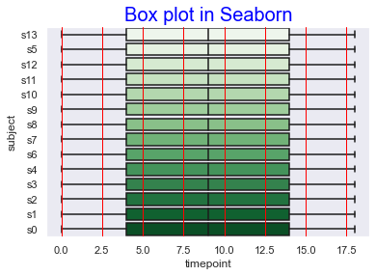



**ii)Histogram**

**Program:**

import numpy as np

import pandas as pd

import seaborn as sns

# Load dataset

dataset = sns.load_dataset("fmri")

print(dataset)

sns.histplot(data = dataset, x = "timepoint", kde = True, hue = "region", palette="Greens")

sns.set_style("dark",{'axes.axisbelow':False,'axes.grid':True,'grid.color':'red'})

sns.set_context("notebook",font_scale=1,rc={'figure.figsize':(8,5)})

plt.title("Histogram plot in Seaborn",color="blue",fontsize=20)

p=sns.color_palette("deep")#deep,colorblind,dark,pastel,bright

sns.palplot(p)

plt.show()

**Output:**

subject timepoint event region signal

0 s13 18 stim parietal -0.017552

1 s5 14 stim parietal -0.080883

2 s12 18 stim parietal -0.081033

3 s11 18 stim parietal -0.046134

4 s10 18 stim parietal -0.037970

... ... ... ... ... ...

1059 s0 8 cue frontal 0.018165

1060 s13 7 cue frontal -0.029130

1061 s12 7 cue frontal -0.004939

1062 s11 7 cue frontal -0.025367

1063 s0 0 cue parietal -0.006899

[1064 rows x 5 columns]

Out[87]:

<AxesSubplot:xlabel='timepoint', ylabel='Count'>



